**Assignment 16.1:**

**Given a list of numbers - List[Int] (1, 2, 3, 4, 5, 6, 7, 8, 9, 10)**

**- find the sum of all numbers**

**- find the total elements in the list**

**- calculate the average of the numbers in the list**

**- find the sum of all the even numbers in the list**

**- find the total number of elements in the list divisible by both 5 and 3**

**Start the spark shell**

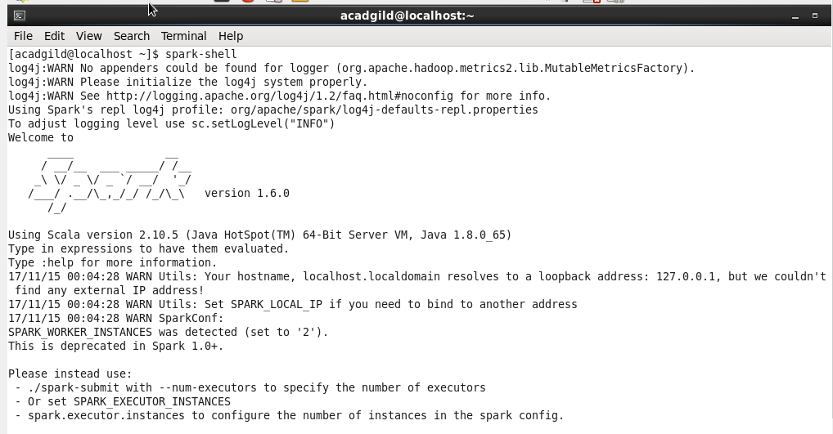

**Load the list of data, and create RDD for the same using spark context.**

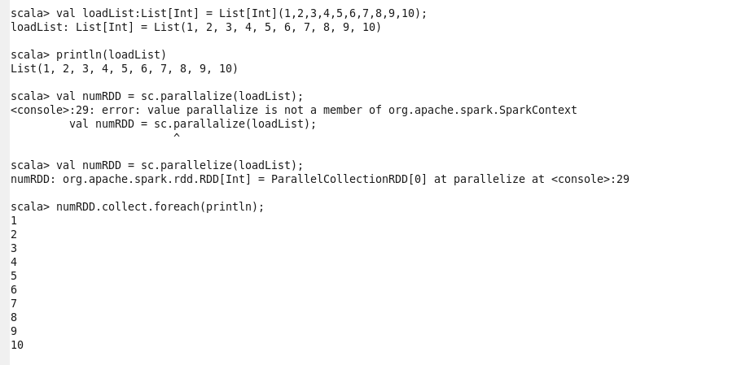

1. **find the sum of all numbers**

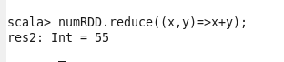

1. **find the total elements in the list**



1. **calculate the average of the numbers in the list  
   **
2. **find the sum of all the even numbers in the list.**

**(**create RDD to find even number, then use same RDD to count sum of even numbers**)**

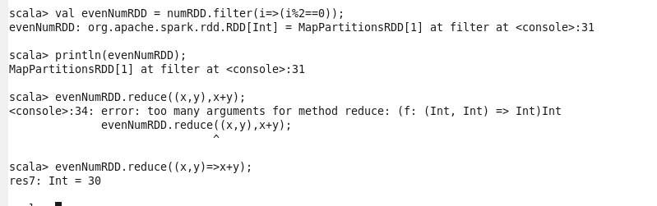

1. **find the total number of elements in the list divisible by both 5 and 3.**

**-get the RDD for number which is divisible by both 5 and 3.**

**- get the count for the same.**

-**get the RDD for number which is divisible by both 5 or 3.**

**-get the count for the same.**

**-get the collection of numbers which is divisible by both 5 and 3.**

